FOR IMMEDIATE RELEASE
May 09, 2018
CONTACT:
Dorothee Bassermann
Tel: +49 8102 8061-63
Email: dorothee.bassermann@asam.net
www.asam.net

Press Release

ASAM XIL Cross-Tests Confirm Users’ Freedom to Choose
The ASAM standardization work group finishes multiple cross-test events to ensure interoperability of commercial test tools based upon the ASAM XIL 2.0.1 standard, effectively enabling engineers in the automotive industry to choose and easily integrate best-in-class ECU testing tools for their application scenarios.

ASAM XIL
ASAM XIL standardizes the interface between test automation tools and the underlying test execution systems, such as model-in-the-loop (MIL), software-in-the-loop (SIL) and hardware-in-the-loop (HIL). This allows test engineers to choose the best tools for their application scenarios and to connect them seamlessly without big integration efforts. Since its first release in 2011, the standard has gained wide adoption in automotive testing. This assures that test cases can run independently of the executing hardware. With this approach, users can create test-cases that can be reused among multiple projects, thus protecting their investment and reducing testing costs.

Cross-Testing – Assessing Interoperability between Commercial Tools
To ensure a smooth user experience, the ASAM XIL standardization working group has carried out a series of cross-testing events to check the interoperability between test automation tools (clients) and in-the-loop test execution tools (servers).

The first cross test, hosted at dSPACE in Paderborn/Germany in 2016, focused on testing the model access port (MA-Port). Already then, the participants confirmed a high degree of compatibility between the tested systems (learn more).

Since then, the electrical error simulation port (EES-Port) has been implemented by the majority of working group members. This became the primary focus of the cross-testing event in October 2017, hosted by National Instruments in Munich/Germany. Typical test-cases of this event have been the testing of wiring errors such as loose contacts, short circuits and broken wires.
The cross-test began by testing the XIL-servers with an ASAM-provided test tool, the ASAM NUnit test-suite. Subsequently, all combinations of client-tools and servers were tested in use-case specific test scenarios, which covered the specific workflow of each test automation tool.

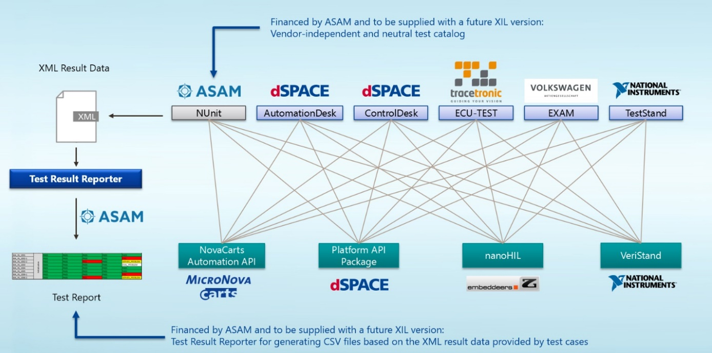
Overview of the EES-Port cross-test

Cross-Testing Results
The event was a great success with a solution-oriented atmosphere and good relations among the participants. The test results were very promising, too. All four server implementations passed 100% of the ASAM NUnit tests for the EES-Port. Clients were cross-tested with each server via use-case specific tests in order to take into account individually defined workflows and usage scenarios of each client. Overall 1291 tests were executed with a 94% passing rate. Some minor interoperability issues were identified and will be fixed.

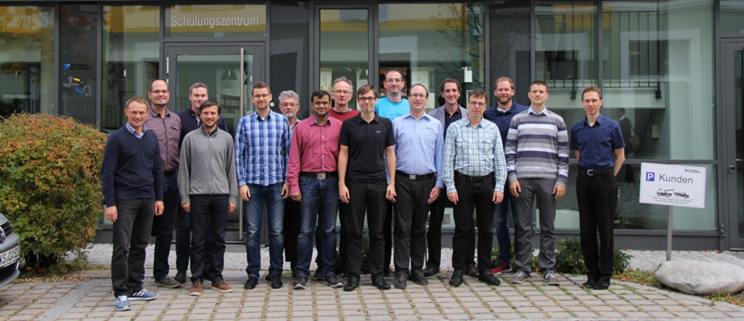
Cross-test participants at National Instruments in Munich/Germany

Next Steps
The latest release, ASAM XIL version 2.1.0, includes a lot of new features like pause simulation, a common interface to real-time scripts, simultaneous read/write, Diag-Port redesign and more. The standardization group agrees to continue working on ASAM XIL and to incorporate feedback from the growing user base as well as findings from the cross-testing events. The next releases are scheduled for version 2.1.1 in 2018 and version 2.1.2 in 2019.
The group also plans to include the ASAM XIL NUnit test-suite with a future release of the standard, which shall serve as a vendor independent, neutral test catalog for the MA-Port and the EES-Port. The advantage of using the test-suite is that tool vendors can check standard conformity of port implementations prior of releasing their product to the market. ASAM encourages all tool vendors to implement the ASAM XIL standard in their products, and to actively contribute their ideas and experience to further improve the standard.

About ASAM e.V.
ASAM e.V. (Association for Standardization of Automotive and Measuring Systems) is actively promoting standardization within the Automotive Industry. Together with its more than 200 member companies worldwide, the association develops standards that define interfaces and data models for tools used for the development and testing of electronic control units (ECUs) and for the validation of the entire vehicle. (www.asam.net)

