FOR IMMEDIATE RELEASE
April 05,2023
CONTACT:
Dorothée Bassermann
Tel: +49 8102 70139-085
Email: dorothee.bassermann@asam.net
www.asam.net

Press Release
ASAM has a new Board of Directors

The ASAM membership has elected a new Board for the term 2023 - 2025. Dr. René Grosspietsch (BMW AG), Prof. Dr. Frank Köster (DLR e.V.), Dr. Ralf Nörenberg (HighQSoft GmbH) and Armin Rupalla (RA Consulting GmbH) were confirmed in office. Dr. Andras Kemeny (Driving Simulation Association) was newly elected to the board and replaces Prof. Dr. Marcus Rieker.

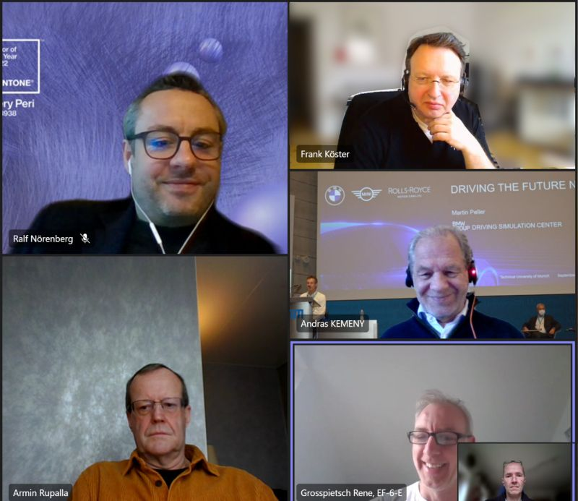
Hoehenkirchen, Germany – April 05, 2023 – At the ASAM General Assembly on March 21, 2023, Dr. Andras Kemeny (Driving Simulation Association) was elected as new member of the ASAM Board of Directors. He replaces Prof. Dr. Marcus Rieker (Horiba Europe GmbH). Prof. Dr. Rieker has shaped ASAM over 14 years as a member of the Board, including four years as Chairman. He significantly influenced ASAM’s strategy and drove its growth. We thank Prof. Dr. Rieker for his commitment and support throughout the years and look forward to a continuous collaboration in the future.
The new ASAM Board of Directors:
Left column, from top down: Dr. Ralf Nörenberg, Armin Rupalla. Right column, from top down: Prof. Dr. Frank Köster, Dr. Andras Kemeny, Dr. René Grosspietsch. (Quelle: ASAM e.V.)

Dr. Andras Kemeny, President of the Driving Simulation Association, was newly elected to the ASAM Board. Dr. Kemeny has many years of experience in the field of simulation, both on the OEM side and on the academic side. During his term of office, Dr. Kemeny wants to intensify ASAM’s relations with European authorities.

In the constituent meeting of the ASAM Board of Directors on March 30, 2023, Armin Rupalla (RA Consulting GmbH) was elected as the new Chairman of the Board. Mr. Rupalla has a long-standing and close affiliation to ASAM. We are pleased that he will serve ASAM in a new role during this upcoming term.

In its term 2023 – 2025, the Board will focus on driving the association’s internationalization and on developing the ASAM standards portfolio. The standardization domain "Simulation", which supports the implementation of highly automated and autonomous driving, shall be further enhanced and aligned with activities in the other domains. The Board also intends to further increase cooperation with other standardization organizations and to participate in publicly funded projects.

About ASAM e.V.
ASAM e.V. actively promotes standardization for automotive development and testing of ECUs and for the validation of the entire vehicle. Together with its 400+ member companies worldwide, ASAM develops standards that enable easy integration of tools into existing value chains and a seamless data exchange. The ASAM portfolio comprises 37 standards that are applied in the automotive industry worldwide. (www.asam.net)

