FOR IMMEDIATE RELEASE
May 10, 2022
CONTACT:
Dorothée Bassermann
Tel: +49 8102 8061-63
Email: dorothee.bassermann@asam.net
www.asam.net

Press Release

Change in the Management of ASAM e.V.
Starting May 01, 2022, the standardization organization ASAM e.V. is led by a new management team. Marius Dupuis takes on the role of Chief Executive Officer (CEO) and Benjamin Engel the newly created position of Chief Technology Officer (CTO). The expansion of the management team has become necessary due to the strong growth in membership in recent years and the resulting increase in complexity of the tasks.

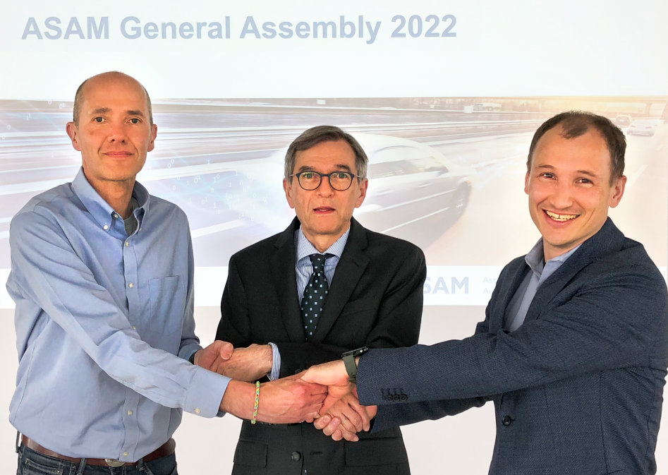
Hoehenkirchen, Germany (May 10, 2022) – As of May 1, 2022, Marius Dupuis will take over as Chief Executive Officer from Dr. Klaus Estenfeld, who has held the position of Managing Director on an interim basis since February 2022. In this role, Mr. Dupuis is responsible for the membership management worldwide and for the strategic direction of the organization. Before joining ASAM, Marius Dupuis was owner and managing director of VIRES Simulationstechnologie GmbH for more than 20 years and most recently worked as managing director of the VIRES Business Unit within the Hexagon Group. He has gained profound knowledge in the field of simulation-based testing for ADAS and AD. After leaving Hexagon, he founded two start-ups which he will continue to support alongside his role at ASAM.
From left to right: Marius Dupuis (CEO), Dr. Klaus Estenfeld (Interim Managing Director), Benjamin Engel (CTO)

Simultaneously, Benjamin Engel has been appointed Chief Technology Officer (CTO). In this newly created position, he is responsible for the technical development and alignment of the ASAM standards as well as for the technical team at ASAM. In his previous roles as a Global Technology Manager at ASAM and as a Team Lead in CAE he gained a deep knowledge of simulation for automotive, particularly on virtual V&V for AD/ADAS.

Marius Dupuis is looking forward to his new task: "After working in a strong and established corporate environment, the management and development of ASAM e.V. brings me back to my roots and offers me all the fascination and momentum that you would usually only expect from start-ups. "

Benjamin Engel emphasizes, " In view of the many challenges that autonomous driving poses to the automotive industry, I am convinced that we can only overcome them together. ASAM provides the ideal framework for industry and science to pursue our common goals. I am looking forward to this task."

"With the reorganization of the ASAM management, we are preparing the association for the challenges ahead. We are pleased that Marius Dupuis and Benjamin Engel, two experienced executives, are taking on this challenge and look forward to a successful cooperation" says Marcus Rieker, Chairman of the ASAM e.V. Board of Directors.

ASAM e.V.
ASAM e.V. (Association for Standardization of Automation and Measuring Systems) is actively promoting standardization within the Automotive Industry. Together with its currently more than 380 member organizations worldwide, the association develops standards in the area of automotive electronic engineering that define interfaces and data models for tools used for the development and testing of electronic control units (ECUs) and for the validation of the entire vehicle. ASAM is the legal representative of 35 standards that are applied in the automotive industry worldwide.
(www.asam.net)

