FOR IMMEDIATE RELEASE
July 10, 2019
CONTACT:
Dorothée Bassermann
Tel: +49 8102 8061-63
Email: dorothee.bassermann@asam.net
www.asam.net

Press Release

ASAM Plans Cooperation with CATARC to Enter Chinese Market
ASAM e.V., a renowned standardization organization in the automotive industry, and CATARC, a Chinese central government-level enterprise, have signed a Memorandum of Understanding with the intention to enter into a strategic cooperation to promote innovation and ASAM standardization in China.

Höhenkirchen, GERMANY – July 10, 2019 – ASAM (Association for Standardization of Automation and Measuring Systems) and CATARC (China Automotive Technology and Research Center) have agreed to cooperate on the Chinese market. Therefore, they have signed a Memorandum of Understanding on May 17, 2019 in Tianjing, China, to establish a strategic cooperation for promoting innovation and ASAM standardization in the Chinese automotive industry.

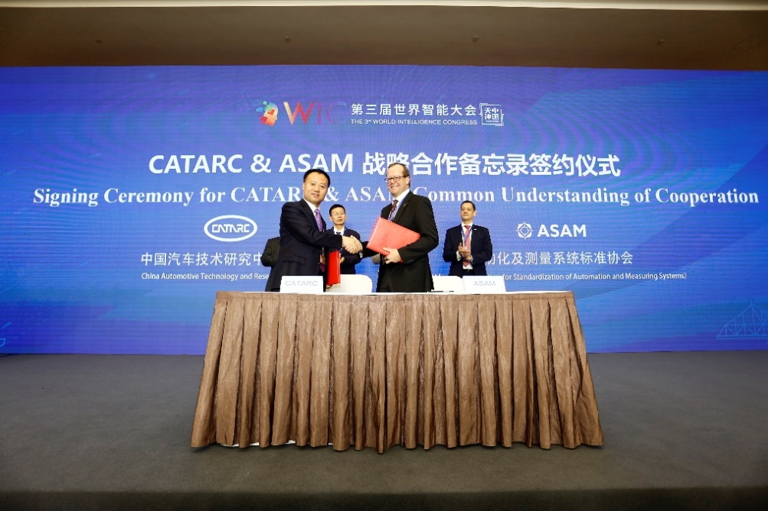
It has been agreed that ASAM will expand its activities to the Chinese market. ASAM aims to promote standardization in the local automotive industry by setting up a standardization process and by providing standards that help to increase efficiency in automotive engineering processes and to improve workflows within Chinese companies.
Jihu Zheng, CEO of CATARC Automotive Data Center (left), and Armin Rupalla, Member of the Board of Directors, ASAM e.V. (right), signing the Memorandum of Understanding (Source: CATARC)

CATARC will cooperate with ASAM in the fields of standardization and project implementation. Additionally it will support ASAM in acquiring and integrating new members from China. As governmental organization, CATARC will also offer support in administrative and legal issues.

For the further cooperation, ASAM and CATARC have agreed to establish a workgroup called “C-ASAM”. This workgroup shall represent ASAM in the Chinese market and make sure that the vision and development plan of the memorandum will be implemented. C-ASAM will carry out ASAM -relevant research, provide demonstrations and trainings for local companies and promote ASAM standards.

Armin Rupalla, Member of the ASAM Board of Directors, comments: “This cooperation is a leap forward in ASAM’s effort for internationalization. It enables us to broaden the user base of ASAM standards and to gain additional members and expertise for the ASAM community. We are looking forward to a fruitful collaboration.”

Mr. Shuai Zhao, representative of CATARC Automotive Data Center, states: “It is CATARC’s goal to promote innovation and efficiency in China. We believe that ASAM and particularly the ASAM standards will support the local automotive industry to improve the efficiency of their processes. Additionally it enables our companies to collaborate on a global level. We look forward to providing services, both for ASAM and for prospect new ASAM members.”

The final contract to establish C-ASAM is foreseen to be signed before the end of this year.

About ASAM e.V.
ASAM e.V. (Association for Standardization of Automation and Measuring Systems) is actively promoting standardization within the Automotive Industry. Together with its more than 250 member organizations worldwide, the association develops standards that define protocols, interfaces and data models for tools used for the development and testing of electronic control units (ECUs) and for the validation of the total vehicle. Currently, ASAM represents 30 standards that are applied in the automotive industry worldwide with the purpose to enable easy integration of tools into existing value chains and to enable a seamless data exchange. (www.asam.net)

