FOR IMMEDIATE RELEASE
October 01, 2019
CONTACT:
Dorothée Bassermann
Tel: +49 8102 8061-63
Email: dorothee.bassermann@asam.net
www.asam.net

Press Release

BMW transfers Open Simulation Interface (OSI) to ASAM
BMW Group and ASAM e.V. have signed an agreement to further develop the OSI (Open Simulation Interface) Format Specification under the auspices of ASAM. OSI describes a generic interface to sensor models and driving simulators. It is used for the virtual test and validation of highly automated driving functions. With OSI, ASAM is taking steps towards a modern standardization process by using agile, open source software development methods for a greater acceptance within the industry.

Hoehenkirchen, GERMANY – September 26, 2019 – The Open Simulation Interface (OSI) defines a generic interface between automated driving functions, driving simulation frameworks and sensor models. Its long-term goal is to provide users the ability to connect any automated driving function to any driving simulator or sensor. This will simplify integration and significantly strengthen the accessibility and benefits of virtual testing.

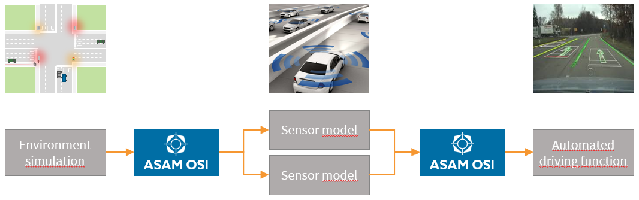
ASAM OSI (© ASAM e.V.)

The BMW Group has decided to pass its rights to OSI on to ASAM, ensuring sufficient, long term support for the standard within a neutral standardization organization. Due to its competence within the simulation domain, ASAM can draw on a great number of experts that will ensure a competent and expedient further development of OSI.

ASAM has decided to employ a completely new approach to its usual standard development model, making use of modern, agile, feature based development. All members of the public will be able to contribute in discussions or with code submissions (latter ones being subject to review by the project group). OSI will be maintained fully open source on the collaborative code platform GitHub with the specification being automatically generated. Automated testing and verification tools ensure a stable code base. The format specification will be renamed to “ASAM OSI”, with releases available on GitHub as well as on the ASAM website free of charge.

Carlo van Driesten, BMW Group, states: “In my vision, developers of automated driving functions should be able to test their function in any driving simulator with ease. Transferring OSI to ASAM brings us closer to this vision. Not only do we have access to a large community of simulation experts but also to a large number of companies who will ultimately integrate OSI in their simulation environments. The fact that ASAM has decided to continue the development in an open source environment will draw additional users to OSI. I am positive that this all contributes to a strong and internationally accepted standard.”

“Our main goal is to provide standards with a strong market power,” confirms Klaus Estenfeld, Managing Director of ASAM e.V. “For the further development of OSI, we have decided to adapt our policy and allow also contributions by non-members. However, to ensure a homogenous and concerted further development, these contributions must be accepted by the working group. We believe that this is the best way to ensure both strong market penetration of the standard and a professional further development aligned with the industry.”

About OSI (Open Simulation Interface)
As the complexity of automated driving functions rapidly increases, the requirements for test and development methods are growing. Testing in virtual environments offers the advantage of completely controlled and reproducible environment conditions. In this context, OSI defines generic interfaces to ensure modularity, integrability, and interchangeability of the individual components (environment simulation, sensor model, logical model, and function).

This newly transferred specification makes use of the protocol buffer library by Google. It also includes full documentation and additional supporting projects, all of which will be publicly available on ASAM’s website and on GitHub repositories in the very near future. (https://opensimulationinterface.github.io/osi-documentation/)

About ASAM e.V.
For more than 20 years, ASAM e.V. (Association for Standardization of Automation and Measuring Systems) has been actively promoting standardization within the Automotive Industry. Together with its more than 260 member organizations worldwide, the association develops standards that define protocols, interfaces and data models for tools used for the development and testing of electronic control units (ECUs) and for the validation of the total vehicle. Currently, ASAM represents 30 standards that are applied in the automotive industry worldwide with the purpose to enable easy integration of tools into existing value chains and to enable a seamless data exchange. (www.asam.net)

