FOR IMMEDIATE RELEASE
May 30, 2022
CONTACT:
Dorothée Bassermann
Phone: +49 151 6441 2188
Email: dorothee.bassermann@asam.net
www.asam.net

Press Release
Validating autonomous vehicles and driving functions safely and reliably
Safety is a decisive factor in the realization of autonomous driving. ASAM e.V. has addressed the question of which test procedures are needed to make highly and fully automated driving safe. Experts and stakeholders from 24 organizations, including manufacturers, suppliers, testing companies and research institutes, have jointly developed a blueprint that describes this challenge and identifies possible solutions.
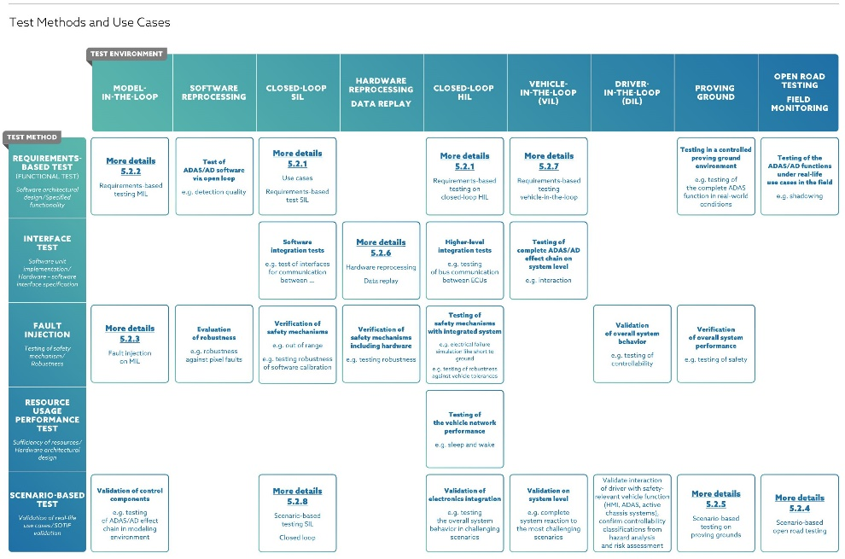
ASAM “Test landscape” overview: Test methods and use cases
Hoehenkirchen, Germany, May 30, 2022 – Driving a vehicle is an extremely complex process, with an infinite number of scenarios that a driver has to cope with. Consequently, transferring the driving task from humans to machines is equally difficult. Autonomous driving (AD) and Advanced Driver Assistance Systems (ADAS) require radical changes in testing methods and new concepts for comprehensive vehicle validation, both for physical and virtual testing. Without cooperation across manufacturers and sectors, and without intensive exchange among all stakeholders, it will not be possible to master this complexity. The use of standards to promote and enable exchange and collaboration is an integral part of meeting this challenge.

An interdisciplinary team of experts from 24 organizations around the world has contributed their knowledge to jointly answer questions such as: What is the state-of-the-art in testing driving functions in a rapidly evolving environment? What are best practices for testing and safely deploying autonomous driving features? How can new technologies, such as artificial intelligence, be integrated? How can the industry deal with the fact that there are currently only few legal requirements, but that in the future more or different requirements will decide on the homologation of vehicles?

The ASAM Test Specification study group, which includes representatives from all stakeholders such as manufacturers, suppliers, testing companies, and research institutes, has published a report providing an overview of different test methods for ADAS and AD and their interaction. One outcome of the project was a "test strategy blueprint" that can serve as a basis for future testing. As a holistic best practice approach, this blueprint can be tailored to the specific requirements of production and other projects, while meeting current regulatory, legal and technical requirements. To develop the blueprint, the group identified detailed use cases for the implementation of a test strategy and aligned them with current standards and standardization initiatives. In the end, the project group derived recommendations for all stakeholders as well as suggestions for further standardization activities.

Benjamin Engel, Chief Technology Officer at ASAM e.V. comments: “When we look at ADAS and AD, we see that collaboration is extremely important. Standards are key if collaboration is to work. The ASAM Test Specification Report is also a call to the industry and other standardization organizations to further drive collaboration and make sure that we reach our common goal of highly automated driving, quickly and safely.“

“Safety is particularly important for software-centered vehicles as well as for autonomous driving functions. To realize safe autonomous driving, many complex and demanding tests need to be performed. The members at ASAM believe that it is valuable and helpful to develop a complete test landscape for the automotive industry, a blueprint and a comprehensive overview of all test procedures that play an important role in the automotive industry.“ summarizes Jann-Eve Stavesand, project leader of the ASAM Test Specification study group and Head of Consulting at dSPACE GmbH.

The report of the project group is addressing all test and safety engineers involved in the validation of autonomous driving functions and highly automated driving. It also addresses all testing and homologation organizations that will be entrusted with the homologation of these functions in the future. The report is freely accessible via the website report.asam.net.

ASAM e.V.
ASAM e.V. (Association for Standardization of Automation and Measuring Systems) is actively promoting standardization within the Automotive Industry. Together with its currently more than 380 member organizations worldwide, the association develops standards in the area of automotive electronic engineering that define interfaces and data models for tools used for the development and testing of electronic control units (ECUs) and for the validation of the entire vehicle. ASAM is the legal representative of 35 standards that are applied in the automotive industry worldwide.
(www.asam.net)

Important links
https://report.asam.net

