FOR IMMEDIATE RELEASE
April 29, 2020
CONTACT:
Dorothée Bassermann
Phone: +49 8102 8061-63
Email: dorothee.bassermann@asam.net
www.asam.net

Press Release
First ASAM Versions of OpenX Standards for the Virtual Development auf Highly Automated Driving Released

After only one year of intensive project work, ASAM (Association for Standardization of Automation and Measuring Systems) has now released ASAM OpenDRIVE V1.6.0© and ASAM OpenSCENARIO© V1.0.0 The three complementary standards OpenDRIVE (description of road network), OpenCRG (description of road surface), and OpenSCENARIO (description of dynamic content) were handed over to ASAM at the end of 2018, the project work began in 2019. The newly released versions contain significant improvements and can be downloaded from the ASAM website free of charge.

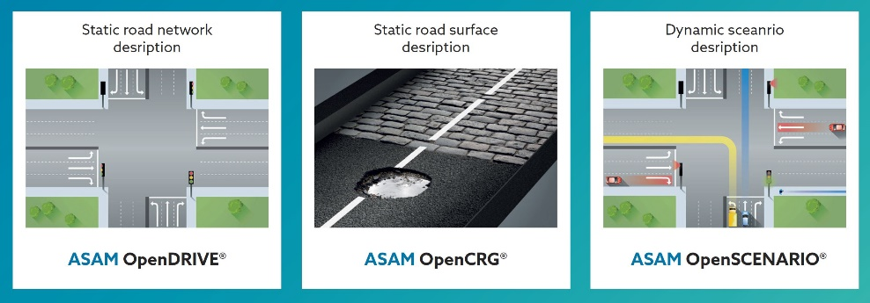
Hoehenkirchen, GERMANY – April 29, 2020 –
OpenDRIVE, OpenCRG and OpenSCENARIO were transferred to ASAM in late 2018. In 2019, the first project groups, staffed with international experts for highly automated driving, started their work. Only one year later, ASAM is now announcing the first releases: ASAM OpenDRIVE© V1.6.0 and ASAM OpenSCENARIO© V1.0.0 were released last month and are now publicly available free of charge. The release of ASAM OpenCRG© is scheduled for Q4 2020.
ASAM standards for road and scenario description (Source: ASAM e.V.)

Both ASAM OpenDRIVE V1.6.0 and ASAM OpenSCENARIO V1.0.0 are based on their predecessor versions. They now fulfill ASAM’s stringent quality requirements. For both standards a UML Modell has been developed and is now available. Inconsistencies and ambiguities are removed, known errors eliminated and a clearer terminology introduced. With these steps the usability of both standards is significantly improved.

Additional concept projects were launched parallel to these “transfer projects” to discuss required extensions of the respective feature set. The early start of the concept projects allows ASAM to quickly transition into the development of the subsequent versions. The concept paper for ASAM OpenSCENARIO V2.0 is already available, and the project group plans to start work in early June. The concept paper for ASAM OpenDRIVE is expected to be published in August 2020.

The ASAM OpenSCENARIO concept proposes to extend Version 2.0 by a domain-specific language (DSL). The DSL should support all levels of scenario description, from very abstract to very concrete, in a suitable way. The concept group is certain that the planned changes will bring ASAM OpenSCENARIO 2.0 a big step forward.

Both the concept for ASAM OpenDRIVE and ASAM OpenSCENARIO are to be implemented and released within one year, that is in the second half of 2021. Participation in the projects is still open and requires ASAM membership.

"With ASAM OpenDRIVE V1.6.0 and ASAM OpenSCENARIO V1.0.0, ASAM has proven its ability to work professionally and goal-oriented and to deliver results quickly," says Dr. Klaus Estenfeld, managing director of ASAM e.V. He adds: "We see an enormous interest in our simulation projects from our members and also from non-members. This shows the urgent need for solutions in the field of simulated testing and validation. With the new releases we are able to provide improved versions of OpenDRIVE and OpenSCENARIO. Numerous international experts have worked on the concepts for their further development. We believe that the implementation of these concepts will lead to an even broader acceptance of the ASAM OpenX standards".

Download ASAM OpenDRIVE V1.6.0: https://www.asam.net/standards/detail/opendrive/
Download ASAM OpenSCENARIO V1.0.0: https://www.asam.net/standards/detail/openscenario/
Download ASAM OpenSCENARIO Concept: https://www.asam.net/standards/detail/openscenario/

About ASAM e.V.
ASAM e.V. (Association for Standardization of Automation and Measuring Systems) is actively promoting standardization in the automotive industry. Together with its almost 300 member organizations worldwide, the association develops standards that define interfaces and data models for tools used for the development and testing of electronic control units (ECUs) and for the validation of the entire vehicle. The ASAM portfolio currently comprises 32 standards that are applied in tools and tool chains in automotive development worldwide.
(www.asam.net)

