FOR IMMEDIATE RELEASE
October 10, 2019
CONTACT:
Dorothée Bassermann
Tel: +49 8102 8061-63
Email: dorothee.bassermann@asam.net
www.asam.net

Press Release
ASAM and CATARC Launch Joint Initiative to Tap Chinese Market for ASAM Standardization

The standardization organization ASAM e.V. and the Chinese state-owned company CATARC Automotive Data Center jointly launch an initiative to promote the use of ASAM standards in the Chinese automotive industry and to support the development of new ASAM standards as well as the further development of existing ASAM standards according to Chinese requirements. To achieve these goals, a joint organization "C-ASAM" was founded.

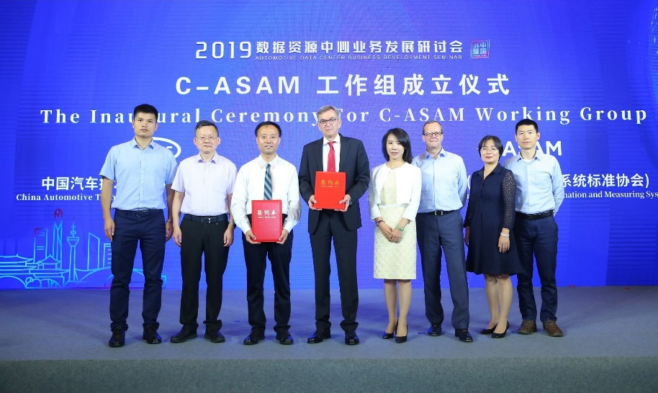
Hoehenkirchen, - October 10, 2019 - In a ceremony held on September 27, 2019, ASAM e.V. (Association for Standardization of Automation and Measuring Systems) and CATARC Automotive Data Center founded a joint organization to establish ASAM in China. The newly formed working group "C-ASAM" has the task to promote interest in ASAM and its standards within the local automotive industry, to
From left to right: Jianshan Yu, director of technical department, Geely; Shijun Yan, director, PATAC; Jihu Zheng, general manager, CATARC Automotive Data Center; Klaus Estenfeld, CEO, ASAM e.V.; Yijing Hui, vice general manager, CATARC Automotive Data Center; Armin Rupalla, Member of the Board of Directors, ASAM e.V.; Lijuan Lu, general manager assistant, GAC FCA; Jianjun Wu, senior director, Chrysler Asia Pacific.

accompany local companies in the use of ASAM standards, to hold training on ASAM standards and to drive the acquisition and integration of Chinese ASAM members. One main goal of C-ASAM is to establish and implement local standardization activities and thus further expand the international acceptance of ASAM standards.

With the foundation of C-ASAM, ASAM is expanding its global footprint to one of the most important automotive markets. After Europe, Japan and the US, ASAM expects a strong membership growth in China within the next few years and a prosperous standardization community.

First activities of C-ASAM in regards to the ASAM OpenX standards in the domain “Simulation” are already in planning. Due to the great amount of new membership requests from China, driven by the cooperation with CATARC, ASAM anticipates a number of standardization impulses from China in the next years.

Dr. Klaus Estenfeld, Managing Director of ASAM e.V., welcomes the joint project: "In recent years, ASAM and CATARC have established a very good and stable relationship. This is based in particular on our common interest in new technologies, such as ADAS and AV, and their successful implementation via the usage of standards. We are convinced that the automotive industry worldwide must work together on these issues and are therefore pleased to have found CATARC as a perfect partner for the dissemination of ASAM standards in China".

Jihu Zheng, General Manager of CATARC Automotive Data Center, also sees the cooperation as positive: "The goal of CATARC ADC is to promote cooperation between the Chinese and the international automotive industry. Standardization is the key to do this. Since ASAM offers some of the leading standards for validating autonomous driving functions, we consider the cooperation with ASAM to be very important in order to bring in the interests of the Chinese automotive industry. We will support local companies in using the ASAM standards effectively and in incorporating their local requirements".

About ASAM e.V.
ASAM e.V. (Association for Standardization of Automation and Measuring Systems) is actively promoting standardization within the Automotive Industry. Together with its more than 270 member organizations worldwide, the association develops standards that define protocols, interfaces and data models for tools used for the development and testing of electronic control units (ECUs) and for the validation of the total vehicle. Currently, ASAM represents 30 standards that are applied in the automotive industry worldwide with the purpose to enable easy integration of tools into existing value chains and to enable a seamless data exchange. (www.asam.net)

About CATARC Automotive Data Center

China Automotive Technology and Research Center Co., Ltd. (CATARC) is a central government-level enterprise belonging to the State-owned Assets Supervision and Administration Commission of the State Council and a comprehensive science and technology corporate group with extensive influence in the automotive industry home and abroad. As one of the most important organizations of CATARC, the Automotive Data Center (ADC) actively promotes the integration of information technologies and industry, provides integrated solutions for the automotive industry to grow sustainably, and establishes a multi-dimensional business framework on the basis of big data, large platforms and huge computation. With one-stop solutions to help the industry and companies to grow, ADC aims to be a national data center for the automotive industry. (www.catarc.ac.cn/ac_en)

