ASAM Guide:SIMULATION

Submission of an Application Story

Deadline: Dec 04, 2020

Thank you for your consideration to submit an application story to ASAM.
For the ASAM Guide:SIMULATION, we seek use cases and stories describing how ASAM standards helped to overcome challenges in automotive development with a particular focus on simulation. This may involve the ASAM OpenX standards or other ASAM standards used in a simulation context. With your time and effort you don’t only support the ASAM organization but you also showcase your company’s expertise in the application of ASAM standards.

To submit an application story, please consider the following requirements:
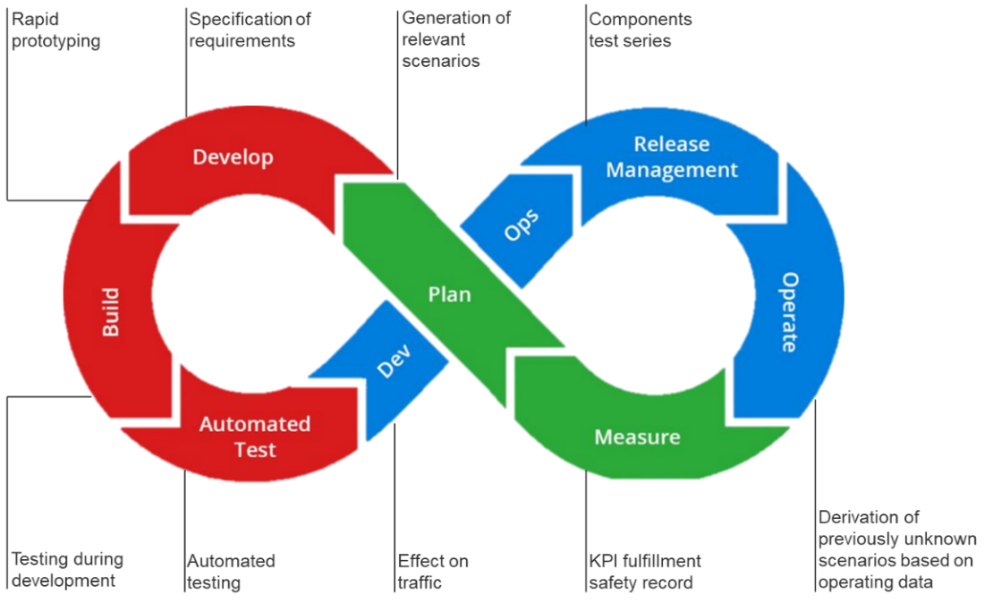
- We are planning to structure the ASAM Guide according to the following rough process:
Please try to map your story to one or more of these process step(s) . If your application story does not fit into the system, please do not hesitate to submit your story anyway.
- Please focus the application story on how ASAM standards have supported and benefitted your workflow and how they have helped to overcome challenges.
- If possible, attach up to two pictures / screenshots / drawings / graphs (jpg or png) and a quote.
- The target group are experts in the area of simulation and automated driving development.
- Please follow the form below to structure your use case or adapt it to your needs.
- Do not exceed 7.500 characters (incl. spaces). This will result in a 2-pager in the brochure.
- Please avoid pure marketing pitches! This is a platform to promote the benefits of the standard technologies and how they benefitted your workflows or products.

What happens to your Application Story after submission?
Application stories will be reviewed before publication and a revision might be required. After your final consent, we will publish your story in the ASAM Guide:Simulation and on our website at www.asam.net
/application-stories/. We may also use further marketing instruments to feature your story.

Important:
ASAM reserves the right to decide on the publication of the application story. In case of too many submissions, a committee will be formed to decide on the acceptance of the story.

Submission:
Please submit your application story as a word document. Pictures should be submitted as jpg or png. If you plan to use another format, please inform dorothee.bassermann@asam.net.
Submission is due by Dec 04, 2020 to dorothee.bassermann@asam.net.

Information on the Submitter

Company:
Author:
Department:
Position:
Graph p. 1
My story fits to the following steps:

Structure

In order to guarantee a consistent reader experience, we ask you to roughly follow the structure below. You may use the structure as a guidance, but feel free to adapt it where needed. Please do not exceed 7.500 characters (incl. spaces).

Part 1: Summary

- Challenge / Problem (1 - 2 sentences)

- Solution (1 - 2 sentences)

- Key benefits (1 - 2 sentences)

Part 2: Application Story

- Description of the Situation
Please describe involved companies, department, project, project environment, etc.

- Initial situation / challenge(s) and problem(s) faced / motivation
What were the reasons for starting this project? What had to be solved / optimized?
Please describe in a generic way, avoid technical details and specific terms.

- Success strategy / solution
Please describe in a generic way, avoid technical details and specific terms. Please point out the ASAM standard your solution is based on.

- Challenges during the project
Did you have expected or unexpected problems during the project?

- Business Benefits
Please avoid a technical description. If possible, use terms like “cost savings”, “time savings”, “gain of flexibility”, “increase of quality”, etc.

Part 3: Personal Quote

Please add a personal quote - if possible from a high ranking company representative or a client (incl. name and position / department). You can start your quote with: “I chose an ASAM based solution, because…” / “I support ASAM because…” / “ASAM provided me … which helped me with …” / etc.

For questions, please contact dorothee.bassermann@asam.net.
Thank you very much for your contribution.

Your ASAM team

