FOR IMMEDIATE RELEASE
January 30, 2020
CONTACT:
Dorothée Bassermann
Tel: +49 8102 8061-63
Email: dorothee.bassermann@asam.net
www.asam.net

Press Release
New ASAM ODS http API -
ASAM ODS Cross Test Shows Great Compatibility Between Servers and Clients

Tool vendors from Germany, Austria, Great Britain, Greece and India tested their servers and clients for interconnectivity and compatibility with ASAM ODS. The test confirmed that nearly all clients and servers could be connected. The client server connection was tested with both, the new http API and the traditional CORBA API.

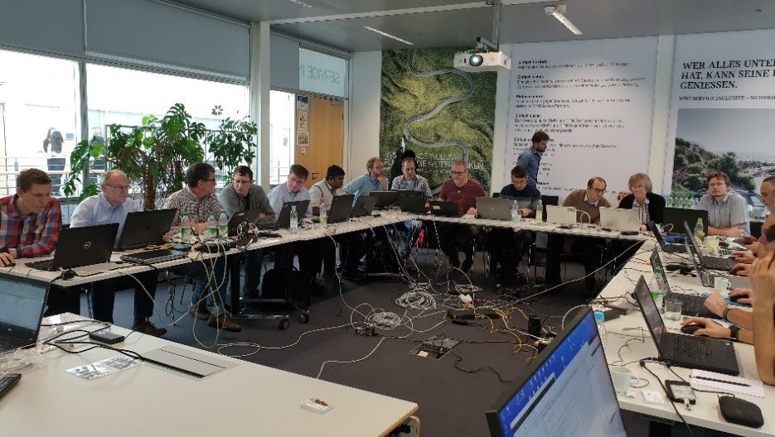
Hoehenkirchen, GERMANY – January 30, 2020 – Twenty participants from Germany, Austria, Great Britain, Greece and India followed the invitation of the ASAM ODS work group to test the compatibility between their servers and clients.
The ASAM ODS Cross Test took place on November 26 and 27, 2019 and was hosted by BMW in their training academy in Unterschleissheim, Germany. Together, there were seven ODS-servers and five ODS-clients that were tested for compatibility.
ASAM ODS Cross Test: Ten international companies are testing the interoperability of their servers and clients. (Source: ASAM e.V.)

The client server connection was tested with two different APIs: the newly introduced http API and the traditional CORBA API. Particularly the test of the http API revealed some ambiguities in the standard which – thanks to a very effective collaboration of the participants – could be clarified quickly. Almost all clients and servers could be successfully connected. Problems in the standard were immediately submitted as change requests for the next ODS release.

Another focus of the Cross Test was to verify, if atfx sample files could be read by all clients and servers. As the tested servers and clients had different coverage of the ODS standard, differing from simple read only servers to full-featured mixed mode servers, the test results differed but all products passed the test.

All participants were happy with the outcome of the test and are looking forward to the next ASAM ODS Cross Test.

The following companies participated in the cross test:
- AVL List GmbH
- BETA CAE Systems SA
- HighQSoft GmbH
- HORIBA
- iASYS technology Solutions Pvt. Ltd
- Kristl, Seibt & Co. GmbH
- Müller-BBM VibroAkustik Systeme GmbH
- National Instruments
- Peak Solution GmbH
- SIEMENS Industry Software

About ASAM Cross Tests
ASAM cross tests serve to verify standard compliant tool interoperability among the products from different vendors.

The participating companies cooperate to verify and improve their software in real life scenarios. Participants help each other to understand the subtle differences in the data formats of different programs and to solve the difficulties that may arise when interpreting this data.
ASAM uses this platform to increase the quality of its standards. Ambiguities and errors are detected and can be corrected in the next version.

The overall objectives of ASAM cross tests are: increased tool interoperability, a better understanding of the standard, potential improvements in the standard, and significantly reduced tool chain integration efforts for end users. (Standard compliance & quality assurance at ASAM ->)

About ASAM e.V.
ASAM e.V. (Association for Standardization of Automation and Measuring Systems) is actively promoting standardization within the Automotive Industry. Together with its more than 240 member organizations worldwide, the association develops standards that define interfaces and data models for tools used for the development and testing of electronic control units (ECUs) and for the validation of the total vehicle. ASAM is the legal representative of 30 standards that are applied in the automotive industry worldwide. (www.asam.net)

