FOR IMMEDIATE RELEASE
June 04, 2019
CONTACT:
Dorothée Bassermann
Tel: +49 8102 8061-63
Email: dorothee.bassermann@asam.net
www.asam.net

Press Release

ASAM Announces Election of New Chairman of the Board
ASAM e.V., a renowned standardization organization in the automotive industry, announces the election of a new Board of Directors for the term 2019 – 2021. In the constitutive meeting, Prof. Dr. Marcus Rieker has been elected as new chairman of the Board.

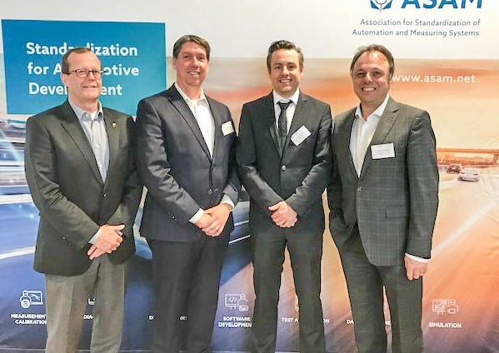
Höhenkirchen, GERMANY – June 04, 2019 – For the next two years, Prof. Dr. Frank Köster (DLR e.V.), Dr. Ralf Nörenberg (HighQSoft GmbH), Prof. Dr. Marcus Rieker (HORIBA Europe GmbH), Armin Rupalla (RA Consulting GmbH) and Richard W. Vreeland (Cummins Inc.) are going to take over the Board activities for the standardization organization ASAM e.V.
The new ASAM Board of Directors (from left to right):
Armin Rupalla, Richard W. Vreeland, Dr. Ralf Nörenberg, Prof. Dr. Marcus Rieker. Not in the picture: Prof. Dr. Frank Köster. (Source: ASAM e.V.)

The ASAM membership has elected Prof. Frank Koester as new member of the Board. Succeeding Mr. Marc Blatter who is no longer available for the position as chairman, Prof. Rieker will take over the chair of the ASAM Board of Directors: “I am very proud to have accompanied ASAM during the past 10 years as member of the Board. The organization has since made a tremendous progress attracting new members and new standardization domains. As chairman, I am eager to continue this progress and ensure a sustainable development of ASAM as an international organization”, he states.

The major tasks of the Board of Directors for the next two years are to continue ASAM’s internationalization and to advance its standardization in new technological areas. In the past year, the organization has expanded its portfolio by the new standardization domain “simulation”. This new domain comprises the “OpenX” standards which describe static road networks and dynamic driving scenarios. They are used for driving and traffic simulation and serve to validate highly automated driving systems. For Prof. Rieker, the integration of these new standards is a top priority: “The integration of the OpenX Standards into the ASAM community requires the implementation of more staff members and the adoption of the internal and external work processes. It is my intention to continue and finalize this process.”

Prof. Rieker actively promotes to continue the discussion on autonomous driving and virtualized development and validation processes. This year’s ASAM International Conference on “Autonomous Driving – Standardized Virtual Development as the Key to Future Mobility” will be one platform for that purpose. This biennial event which will take place on Dec 10 – 11, 2019 in Dresden, attracts more than 200 participants from the automotive industry worldwide and gives them a forum to discuss standardization needs.

About ASAM e.V.
ASAM e.V. (Association for Standardization of Automation and Measuring Systems) is actively promoting standardization within the Automotive Industry. Together with its more than 250 member organizations worldwide, the association develops standards that define protocols, interfaces and data models for tools used for the development and testing of electronic control units (ECUs) and for the validation of the total vehicle. The 30 ASAM standards are applied in the automotive industry worldwide with the purpose to allow easy integration of tools into existing value chains and to enable a seamless data exchange. (www.asam.net)

