FOR IMMEDIATE RELEASE
June 20, 2023
CONTACT:
Dorothée Bassermann
Phone: +49 8102 70139 085
Email: dorothee.bassermann@asam.net
www.asam.net

Press Release
ASAM OpenLabel standard now also used in rail sector for development of automated driving

In order to support research and development on fully automated driving in railroad operations, the German Centre for Rail Traffic Research (DZSF) has published the multisensor dataset "Open Sensor Data for Rail 2023", which was created by FusionSystems GmbH on the basis of sensor data from DB Netz AG / "Digitale Schiene Deutschland". The data is intended to help train automated driving functions using machine learning (ML) techniques, thus improving object recognition in railroad environments. It is the first publicly available dataset specifically for rail traffic that has been collected using a variety of sensors. To enable comparability and reusability of the data, the dataset uses the standardized annotation format ASAM OpenLABEL®.

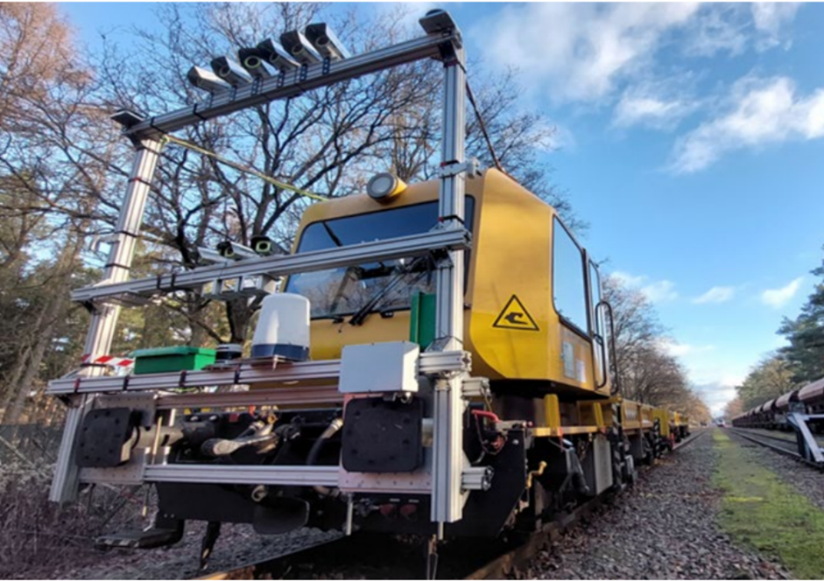
Hoehenkirchen, GERMANY – June 20, 2023 – Just as the automotive industry is developing autonomous driving, the rail industry is working on the realization of fully “automatic train operation” (ATO). One major challenge in future rail operation is object detection: Train paths must be monitored and obstacles must be detected early and reliably so that emergency braking can be initiated in time if necessary. In order to develop automated driving functions that meet these requirements, machine learning methods are used. They require training data, that are ideally collected by different types of sensors. However, the availability of such multi-sensor data for rail traffic has been limited to date.
Sensor configuration on the data collection vehicle (Source: DB Netz AG)

"Open Sensor Data for Rail 2023" (OSDaR23) is the first open multi-sensor dataset for railroads in mainline traffic that provides information from various sensors for training, validation and testing purposes. The dataset was created as part of the project "Preparation of datasets for applications of automated driving in railroad operations" on behalf of the German Centre for Rail Traffic Research (DZSF) by FusionSystems GmbH, using sensor data from DB Netz AG / Digitale Schiene Deutschland. The data was collected by infrared cameras, color imaging cameras, as well as LiDAR, radar, position and acceleration sensors.

The goal of publishing OSDaR23 is to train, test, and validate software systems with machine learning (ML) techniques and to improve the automated environment perception on railways. To be able to exchange and reuse the data, it must be readable and understandable by all users. To ensure this, the project group has chosen ASAM OpenLABEL as the standardized format to annotate the data. The standard, which is already well used in the automotive industry, specifies how object information must be categorized and described in order to provide autonomous driving systems with a common fundamental and in-depth understanding of their environment. Communication problems between systems which can lead to accidents in real life are thus avoided.

ASAM OpenLABEL was developed and published by the standardization organization ASAM e.V. in 2021. Research projects in the automotive sector, such as AVEAS, SUNRISE or SET Level, as well as private companies are already using ASAM OpenLABEL successfully. The standard is part of the ASAM OpenX® family, which is gradually becoming the industry-wide reference for simulation-based testing of automated driving functions in the automotive industry. ASAM OpenLABEL is being maintained and further developed by ASAM e.V. according to the requirements of the industry. A user meeting will be held at the end of 2023 to review the standard and check its technological and content-related requirements and to determine further development steps.

ASAM OpenLABEL is available free of charge at https://www.asam.net/standards/detail/openlabel/. OSDaR23 can be downloaded at https://data.fid-move.de/dataset/osdar23. The research report and the annotation guide for the project will be published shortly via the DZSF website (https://www.dzsf.bund.de). The guide describes how the annotations were created and how future datasets can be annotated in a similar way. In addition, DB Netz AG has published a development library for easy use of the dataset in Python (github.com/DSD-DBS/raillabel) and the Vicomtech Research Foundation provided “WebLabel Player” to visualize the dataset (www.vicomtech.org/en/).

Further reading
About ASAM OpenLABEL: https://www.asam.net/standards/detail/openlabel/
About OSDaR23: https://digitale-schiene-deutschland.de/Downloads/ETR-OSDaR23.pdf
https://arxiv.org/abs/2305.03001
Project information: Link

About ASAM e.V.
ASAM e.V. is a non-profit organization that promotes standardization in automotive development. Together with its more than 400 member companies, ASAM develops standards that enable easy exchange of data and tools within and across tool chains. ASAM standards span a wide range of use cases in automotive verification and validation (V&V) and are in use worldwide.

The ASAM OpenX® standards in particular aim to provide a complete set of standards for simulation-based testing of automated driving functions. They cover a wide range of use cases for virtual development, including hybrid testing approaches that combine virtual and physical components. ASAM OpenX standards are gradually becoming the industry’s reference for their respective use cases and are supported by a majority of simulation tool providers and manufacturers worldwide. (www.asam.net)

