FOR IMMEDIATE RELEASE
Apr 22, 2021
CONTACT:
Dorothée Bassermann
Tel: +49 8102 8061-63
Email: dorothee.bassermann@asam.net
www.asam.net

Press Release
New Board Member and Management at ASAM e.V.

ASAM e.V., an international standardization organization in automotive electronics announces important personnel changes with the beginning of the second quarter of 2021.
- Board of Directors: Dr. René Grosspietsch (BMW AG) was elected to the ASAM Board of Directors at this year's General Assembly. He replaces Richard Vreeland (Cummins Inc), who did not run again. All other board members retain their positions. Prof. Marcus Rieker (Horiba Europe GmbH) was confirmed as Chairman of the Board.
- Management: Since 01.04.2021, Peter Voss is the new Managing Director of ASAM e.V. He takes over this task from Dr. Klaus Estenfeld, who will pursue other responsibilities within ASAM.
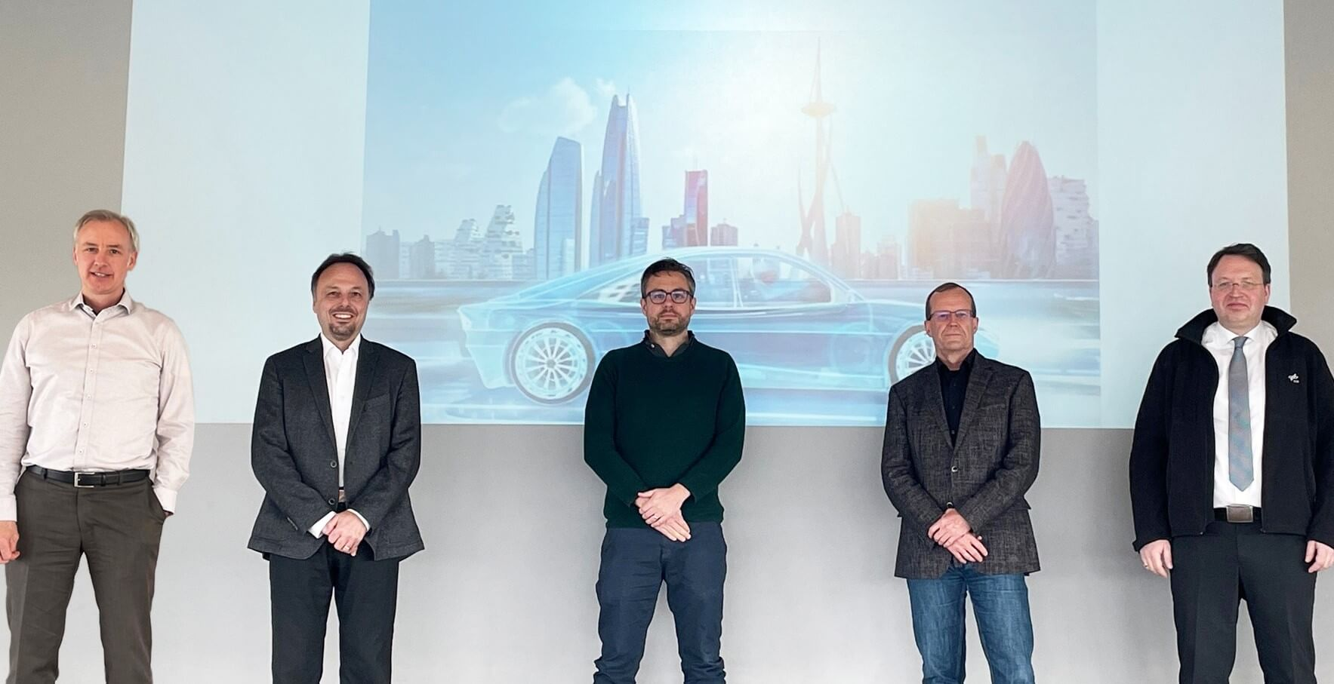
Hoehenkirchen, Germany - April 21, 2021 - Dr. René Grosspietsch (BMW AG) was elected as a new member of the ASAM Board of Directors at the General Assembly on March 24, 2021. He replaces Richard Vreeland (Cummins Inc.), who did not run for the board position. During his career, Dr. Grosspietsch has gained extensive experience in the areas of strategy and innovation management, especially with regard to the validation of driver assistance systems. "I am convinced that the validation and market introduction of autonomous driving functions require a common technological basis and global understanding of the automotive industry. Standards play a very important role in that regard," said Dr. Grosspietsch before his election to the board.
ASAM Board of Directors, term 2021 – 2023 (From left to right: Dr. René Grosspietsch (BMW AG), Prof. Marcus Rieker, Chairman (HORIBA Europe GmbH), Dr. Ralf Nörenberg (HighQSoft GmbH), Armin Rupalla (RA Consulting GmbH), Prof. Frank Köster (DLR e.V.)
Source: ASAM e.V.

Prof. Marcus Rieker (Horiba Europe GmbH) was confirmed in his position as Chairman of the Board during the constituent meeting of the ASAM Board on April 20, 2021. Prof. Rieker has a long-standing and close relationship with ASAM: The new term of office is his seventh on the ASAM Board and his second as Chairman of the Board. He had also been involved in ASAM working groups for many years before his board membership. "Throughout my career, ASAM has always been part of my work. I have seen how great the organization has evolved over the years. Now there are new challenges ahead, which I will be happy to tackle together with my colleagues on the Executive Board," Prof. Rieker summed up on the occasion of his re-election.

Thus, Prof. Marcus Rieker (HORIBA Europe GmbH), Dr. René Grosspietsch (BMW AG), Prof. Frank Köster (DLR e.V.), Dr. Ralf Nörenberg (HighQSoft GmbH) and Armin Rupalla (RA Consulting GmbH) will continue the board activities for the next two years.

The major tasks of the Board of Directors will be to continue the internationalization of the organization and to further develop the ASAM standards portfolio. The new standardization domain "Simulation", which supports the implementation of highly automated and autonomous driving, shall be further extended and merged with activities in the classic domains. For the Board of Directors, cooperation with other standardization organizations and participation in publicly funded projects is another important strategic point.

General Management
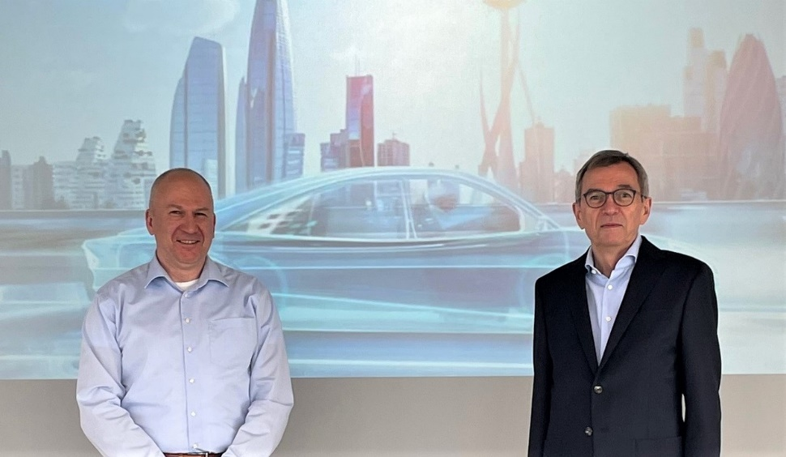
At the same time, ASAM announces another recruitment: Peter Voss has taken over the position of Managing Director at ASAM e.V. as of 01.04.2021. He succeeds Dr. Klaus Estenfeld, who is leaving this position after five years. Prof. Marcus Rieker, Chairman of the ASAM Board of Directors, pays tribute to Dr. Estenfeld's work: "The last 5 years that Dr. Estenfeld has served as Managing Director have been exceptional for ASAM e.V. in every aspect. We thank him for his intensive and very successful work as well as his tireless commitment. At the same time, we are pleased to have been able to win Mr. Voss as our new Managing Director. We are convinced that Mr. Voss, together with the experienced ASAM team, will further develop our organization and drive it to new peaks." Dr. Estenfeld will continue to serve ASAM as an Executive Advisor.
Peter Voss (left) is new Managing Director at ASAM e.V. He has taken over from Dr. Klaus Estenfeld (right) who is leaving this position after five years.
Source. ASAM e.V.

About ASAM e.V.
ASAM e.V. (Association for Standardization of Automation and Measuring Systems) is actively promoting standardization in the automotive industry. Together with its more than 350 member organizations worldwide, the association develops standards that define interfaces and data models for tools used for the development and testing of electronic control units (ECUs) and for the validation of the entire vehicle. The ASAM portfolio currently comprises 33 standards that are applied in tools and tool chains in automotive development worldwide.
(www.asam.net)

